**IM3080 Design and Innovation Project (AY2021/22 Semester 1)**

**Individual Report**

Name: Lee Yi Xuan

Group No: 4

Project Title: Busmeet

**Contributions to the Project** (1-2 page)

**Prototyping**

I initially worked on prototyping the general application on Figma using the 1.0 applications BusLeh! and Glympse before later focusing on the high-fidelity prototype of the process for avatar customization and selection (Figure 1).

*Figure 1: Prototype for avatar customization*

**Drawing of Assets**

For our customizable avatars, I drew every single asset from scratch along with the mascot of Professor Chua (Figure 2) to be used for the log in page and walkthrough using Clip Studio Paint. I also had to sort the avatar assets into 150 (out of 400 possible permutations) end cases for better ease of implementation in the actual application (Figure 3).

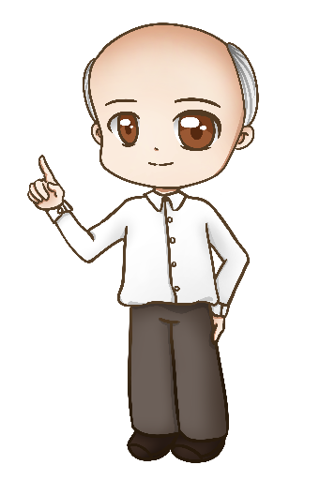

*Figure 2: Professor Chua mascot Figure 3: Files of 150 selected end cases*

For better user interface standardization, I referenced the ideas for the bus and mrt icons from Pheobe and redrew them (Figure 4 & 5).

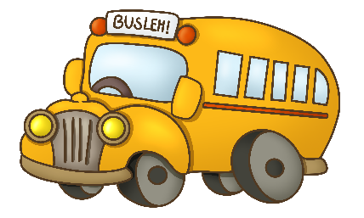 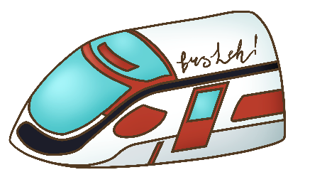

*Figure 4: Standardized Bus Icon Figure 5: Standardized MRT Icon*

As I was very experienced in using Adobe Illustrator, I also helped Sebestian in making our application logo a higher quality by making it into a vector image.

**UI/UX**

I was part of the UI/UX team where I regularly pushed for updates and delegation of work. Overall, I worked with Pheobe and Jingyi to decide on the general UI/UX components such as the colour scheme (Figure 6) and overall theme of the application. We worked well as a team and made many of these decisions on the components together.



*Figure 6: Colour scheme*

For the customizable avatars, I came up with the idea and worked on the whole process alone as seen from all the assets I drew. I feel like that was my biggest contribution to the UI/UX team as we standardized most of our components and ideas to fit with the avatars.

**Final Submission**

For our submission, I helped with the design of our poster on Canva and wrote the bulk of the content for it to better market our application (Figure 7).

*Figure 7: Poster in Canva*

For our final report, as I am part of the UI/UX team and in charge of our avatar, I wrote the content for those portions along with the content on the program I used the most through this project, Clip Studio Paint.

**Miscellaneous**

To facilitate administrative matters such as polling and reminders for meetings, I introduced a discord bot into our discord server and set up timings and reminders through it (Figure 8 & 9) I also helped every week with editing and creating our presentation slides.

*Figure 8: Creation of Meeting Figure 9: Reminder before Meeting*

**Reflection on Learning Outcome Attainment**

**Reflect on your experience during your project and the achievements you have relating to at least two of the points below:**

1. Engineering knowledge
2. Problem Analysis
3. Investigation
4. Design/development of Solutions
5. Modern Tool Usage
6. The Engineer and Society
7. Environment and Sustainability
8. Ethics
9. Individual and Team Work
10. Communication
11. Project Management and Finance
12. Lifelong Learning

**Point 1: Communication**

After the presentation in week 6, it was clear that our group needed to catch up with other groups as we did not have a theme for our application, were unclear of our goals and behind on coding. I felt like this was mainly due to our group leader silently taking on most of the coding himself without communicating to the other members what needed to be done and what he was working on. Furthermore, some group members were only communicating with some of their friends privately instead of with the entire group, leading to further confusion from others that were not in their private chats. Even after we sorted ourselves into the coding team and the UI/UX team, many things were still up in the air. I quickly tried to get the UI/UX team running by creating our own discord text channel and started to work out the jobs we needed to complete and delegate these jobs. However, I realized that many of my friends in the coding team were still unclear and as a result, the UI/UX team could not work on some projects like creating icons when the coding team has not told us the assets they needed.

Initially, I felt like I might be overstepping my role because I was not the group leader, but I decided to introduce an intervention to push for better communication in the group. To do this, I asked some members about what they needed clarifications on and complied a list of questions to tackle and sent it in our group chat. Our group leader was very ready to take the questions and give us answers after he had time to think but I pushed for scheduling a meeting to discuss them as a group instead. In the end, I think this was a paramount turning point for the group and everyone was able to clear up their doubts better and decide on our next course of action as a group. It also helped in delegating jobs for everyone, helping us all get to contribute.

Overall, this experience has led me to realize the importance of directive leadership and communication. In a project such as this where the group consist of so many strangers, it is extremely important for a leader to communicate with everyone and delegate the jobs, also known as being a directive leader in business concepts. Being a leader does not mean taking up the project alone and doing that without communicating with other group members will eventually be detrimental. Additionally, being a group member does not mean you cannot introduce conflict and challenge the leader if it aids in communication. I believe that communication will always be a two-way channel and I am glad I chose to intervene when I did as it really improved communication within the group in the long run.

**Point 2: Modern Tool Usage**

Throughout the project, there were many tools we made use of to produce our final application. As we worked on a software project, we had the luxury of using and learning various software and platforms that provided us with more convenience.

Even though I know of Figma from a previous module, I did not have the chance to use it until this project. As a prototyping tool, it was easy to understand and provided many functionalities which made it easy to edit our prototypes and collaborate on it. Compared to using pen and paper to draw out such prototypes or describing them with words, it was incredibly convenient to visualize our ideas using Figma and I am excited to explore more of its function in the future as someone who is interested in pursuing more user interface design in the future.

Additionally, I wanted to point out the immense convenient of working on art digitally. As the main artist of the group, I spent weeks on drawing and coloring assets for this project on Clip Studio Paint. Even though I was already familiar with the tool, the idea of customizable avatars was new to me in terms of figuring the drawings out. On paper, it would be near impossible to draw various hair and clothing options to match the specifications of the base exactly. However, with the function of layers and using transparencies to make the base a reference layer, it was very convenient and helpful for creating the customizable assets. Furthermore, I initially wanted to introduce different color options for each asset to increase the customizability of the avatars even more. This was not implemented due to lack of time, but it was very plausible due to the functionalities for color adjustments using the software.

Other platforms such as Canva and Github was also introduced to me through this project. Canva provided me with ready made assets for creating the poster which I found easy to use whereas Github was a bit more confusing for me. However, I am thankful the project allowed me to learn Github as I believe it is an essential collaboration platform for engineers.

Overall, what stood out to me about these modern tools is the convenience they provide. Many of the tools help us accelerate processes, making the creation of our application in this short period of time possible. Especially when it comes to digital art, even though I spent over 30 hours drawing for the project, doing so on pen and paper would have taken more than triple the amount of time. This made me really appreciate the efficiency of modern tools and I greatly admire the engineers who created these tools for the world.